AIR QUALITY ANALYSIS AND VISUALISATION
J. Nikhila  Department of CSE  KL University  Bachupally, Hyderabad, India  2420030387@klh.edu.in | S. Srinika  Department of CSE  KL University  Bachupally, Hyderabad, India  2420030617@klh.edu.in | Dr. N. Sunanda  Department of Computer Science and Engineering  KL University  Bachupally, Hyderabad, India

Abstract—Air pollution is a complex environmental issue involving particulate matter, gaseous pollutants, and changing conditions across locations and time. This paper presents an exploratory data-analysis and visualization workflow for Indian city-level air-quality observations from 2015 to 2020. The selected Kaggle dataset contains daily measurements for 26 cities and variables including PM2.5, PM10, NO, NO2, NOx, NH3, CO, SO2, O3, Benzene, Toluene, Xylene, AQI, and AQI category. The study discusses data inspection, missing-value handling, date and city organization, descriptive statistics, AQI-category distribution, pollutant comparison, and city-wise visualization. It reviews eight related research studies covering air-pollution visualization, learning-based analysis, pollutant modelling, Hyderabad air-quality trends, and limitations of city-level reporting. The numerical figures presented in the results section are explicitly identified as reference summaries reported by public analyses of the same dataset, rather than independently recomputed estimates. The paper demonstrates how an organized exploratory workflow can make a multi-variable environmental dataset easier to inspect and interpret, while recognizing the limitations of missing observations and city-level aggregation.
Index Terms—air quality, AQI, data visualization, PM2.5, PM10, exploratory data analysis, India, Python.

I. INTRODUCTION
Air pollution is one of the major environmental challenges associated with urbanisation, industrial development, transportation, energy consumption, and changing patterns of land use. Rapid population growth in cities increases the demand for vehicles, electricity, construction, and industrial activity. These activities can release particulate matter and gaseous pollutants into the atmosphere. The resulting pollution is not limited to a single source or substance; it is a complex mixture whose concentration and composition vary across locations, seasons, weather conditions, and human activities. For this reason, understanding air quality requires the examination of several pollutants together rather than relying on one measurement alone.
Particulate matter is an important component of air pollution. PM2.5 refers to particles with an aerodynamic diameter of 2.5 micrometres or smaller, while PM10 includes particles with a diameter of 10 micrometres or smaller. Because of their small size, fine particles can remain suspended in the atmosphere and may penetrate deeply into the respiratory system. Along with particulate matter, air-quality monitoring commonly considers gases such as nitrogen dioxide (NO2), sulphur dioxide (SO2), carbon monoxide (CO), ozone (O3), ammonia (NH3), and nitrogen oxides (NOx). These pollutants may be associated with different emission sources and atmospheric processes. Their concentrations can also change in response to traffic density, fuel combustion, industrial activity, weather, and seasonal conditions.
The Air Quality Index (AQI) provides a simplified way to communicate complex air-pollution measurements. Instead of requiring readers to interpret several pollutant concentrations independently, an AQI value and its associated category provide an accessible indication of the overall air-quality condition under the applicable index methodology. Categories such as Good, Satisfactory, Moderate, Poor, Very Poor, and Severe help communicate the relative level of concern to the public. However, the index is a summary measure. It does not remove the need to examine individual pollutants, understand the measurement period, or consider differences between monitoring locations. A city-level average can also conceal neighbourhood-level variation and short-duration pollution episodes.
Air-quality monitoring programmes generate datasets containing observations across many dates, cities, stations, and pollutant variables. These datasets are valuable for environmental assessment, policy discussion, and public awareness, but their size and structure can make direct interpretation difficult. A tabular file may contain thousands of rows and multiple numeric columns, along with dates, city names, and categorical AQI labels. Patterns such as changes over time, differences between cities, frequently occurring AQI categories, or relationships among pollutants are not always obvious from a raw spreadsheet. Data science offers a systematic way to inspect, organize, summarize, and communicate such information.
Exploratory Data Analysis (EDA) is an important early stage in this process. It involves understanding the structure of the dataset, checking data types, identifying missing observations, examining distributions, calculating descriptive statistics, and exploring relationships between variables. In air-quality data, these checks are particularly important because monitoring records may be incomplete. Some pollutants may not be measured on every date, and the number of available observations may differ between columns or cities. If missing values are ignored without inspection, summary statistics and visualizations may give a misleading impression. Therefore, data-quality assessment and transparent handling of missing observations are essential parts of a reliable analysis.
Visualization complements statistical analysis by presenting information in forms that are easier to interpret. Bar charts can compare AQI categories or city-level summaries; line charts can show changes across dates; histograms can describe the distribution of pollutant concentrations; box plots can reveal spread and potential outliers; and correlation heatmaps can summarize pairwise linear relationships among numeric variables. No single chart explains every aspect of air quality. Selecting a visualization should depend on the analytical question, the data type, and the level of detail that needs to be communicated. Clear labels, readable scales, consistent category ordering, and appropriate captions are also necessary for effective interpretation.
Several research studies have demonstrated the value of combining air-quality data with visualization, statistical analysis, and machine-learning methods. The literature relevant to this project includes visualization-oriented exploration [1], learning-based visual analytics [2], multi-pollutant modelling [3], Hyderabad air-quality analysis [4], and the limitations of city-level reporting [5]. Additional nationwide studies examine long-term PM2.5 modelling [9], pollutant trends across hundreds of Indian cities [10], and the spatial identification of PM2.5 hotspots [11]. These studies provide a foundation for the eight-paper review presented in the Related Work section.
Despite the availability of advanced modelling approaches, a well-structured exploratory study remains useful. Before forecasting or classification models are developed, it is necessary to understand what the available data contain, how complete the observations are, and whether the variables exhibit meaningful patterns. An exploratory workflow can also make the dataset more accessible to students and readers who are learning how environmental data can be analysed using programming and visualization tools. The present project adopts this approach and focuses on describing the selected dataset rather than claiming to predict future pollution levels or establish causal relationships.
This paper presents an exploratory analysis and visualization workflow using the publicly available Air Quality Data in India dataset for the 2015–2020 period [6]. The city-day dataset used in the study contains observations for 26 Indian cities and includes particulate pollutants, gaseous pollutants, AQI values, and AQI category labels. The work is organized around data inspection, preprocessing, descriptive summaries, AQI-category analysis, pollutant-level comparison, and city-wise AQI visualization. Publicly reported summaries from analyses of the same dataset are used as reference results in the current paper [7], [8]; they are identified as such and are not represented as newly computed results from an independent execution of the project code.
The main contribution of this project is an accessible and reproducible structure for examining a multi-variable environmental dataset. It demonstrates how common data-science operations can convert raw observations into charts and summaries that support comparison and interpretation. The scope is intentionally limited to exploratory analysis: it does not estimate personal exposure, evaluate health outcomes, identify emission sources, or establish cause-and-effect relationships. The remainder of the paper reviews related studies, describes the dataset and methodology, discusses the reported results and their limitations, and concludes with possible extensions to the analysis.
II. RELATED WORK
Li, Fan, and Mao [1] proposed a visualization-oriented approach for air-pollution data exploration, using data-quality assessment as an initial step before presenting multiple visual views. Their work illustrates how bar charts, line charts, heat matrices, scatter plots, and geographic visualizations can be used together to examine different dimensions of air pollution. The approach is relevant to the present project because it supports the idea that environmental datasets should be explored through complementary visual forms rather than through a single summary statistic. The current study adopts this general principle by considering category distributions, pollutant summaries, and city-wise comparisons.
Jain and Kaur [2] developed a learning-based visualization application for air-quality evaluation in open-data-centric services. Their study considered pollutants such as NO2, O3, PM10, PM2.5, SO2, and CO, and combined visualization with supervised and unsupervised learning techniques. It also examined air-quality conditions during the COVID-19 period. This work demonstrates how visualization can be integrated with more advanced analytical methods. The present project has a narrower objective: it concentrates on descriptive and exploratory analysis, providing a foundation for understanding the data before predictive methods are considered.
Persis and Ben Amar [3] investigated pollutant profiles and air-quality prediction in scenarios before and during COVID-19 lockdown conditions. Their study used multi-pollutant clustering and predictive models across selected regions, including Delhi and Telangana. The work is relevant because it illustrates that changes in human activity can be studied through pollutant combinations and AQI-related measurements. It also highlights the value of examining multiple pollutants together. Unlike that predictive study, the current project does not attempt to forecast AQI; it focuses on organizing and visualizing historical observations from the selected public dataset.
Mathew et al. [4] conducted a spatio-temporal analysis of air quality in Hyderabad and examined PM2.5 behaviour across different periods. Their study reported seasonal differences and relationships between PM2.5 and other pollutants, and subsequently applied regression and machine-learning techniques for PM2.5 modelling. This research provides a geographically relevant reference for the present work because Hyderabad is part of the broader urban context of the dataset. It also reinforces the importance of temporal analysis: a single overall average may not adequately represent seasonal or short-term changes. The current study includes date-oriented analysis as part of its exploratory workflow, while recognizing that a more detailed seasonal study would require additional processing.
Sharma et al. [5] examined long-term Indian observations and discussed systematic exposure bias that can arise when city-level air-quality reporting is used to represent conditions experienced across an entire city. Their work draws attention to the limitations of aggregated city-level indicators. This is an important consideration when interpreting the city comparisons in the present paper: differences in city averages can be informative, but they do not describe every neighbourhood, monitoring station, or individual exposure condition. The project therefore treats city-level summaries as exploratory comparisons rather than as complete measures of local exposure.
Kumar et al. [9] developed an ensemble machine-learning approach to analyse the spatiotemporal behaviour of PM2.5 across India from 1980 to 2021 using MERRA-2 data. Their work used machine-learning methods, including Random Forest, to reconstruct fine-particle concentrations and examine long-term regional patterns. The study identified the Indo-Gangetic Plain as a region with particularly high PM2.5 concentrations. Although the present project does not reconstruct pollutant concentrations or train a prediction model, this research supports the importance of examining PM2.5 distributions across time and geography. It also provides context for the pollutant-level summaries and city-wise comparisons in our exploratory workflow.
Sharma et al. [10] analysed air-quality trends across 336 Indian cities over 1987–2019 using observations from the National Ambient Air Quality Monitoring Programme. Their study examined PM10, SO2, and NO2 over multiple decades and geographical regions. The authors reported an overall rise in PM10 concentrations after 2006, while SO2 showed a declining trend and NO2 displayed comparatively stable but fluctuating behaviour. This study is closely related to our project because it demonstrates the value of comparing pollutant measurements across cities and over time. Our work applies a more compact exploratory approach to a 2015–2020 city-day dataset and uses descriptive statistics and visualizations to make such comparisons accessible.
Jaganathan et al. [11] conducted a nationwide spatiotemporal analysis of PM2.5 in India for 2008–2019 and used Getis-Ord Gi* statistics to identify persistent, emerging, and declining pollution hotspots. Their analysis found that important pollution hotspots were not limited to major metropolitan areas and that several were located beyond cities already covered by national clean-air programmes. This research highlights the importance of spatial context when interpreting air-quality measurements. The present project uses city-level records rather than a high-resolution geospatial model, but the study reinforces the need to compare locations carefully and to avoid assuming that a national or city average represents every local area.
Overall, the eight research studies reviewed in this paper cover complementary aspects of air-quality analysis: visual exploration [1], learning-based visual analytics [2], pollutant clustering and prediction [3], Hyderabad-specific temporal analysis and PM2.5 modelling [4], limitations of city-level exposure reporting [5], ensemble modelling of PM2.5 across India [9], long-term pollutant trends across 336 Indian cities [10], and nationwide identification of PM2.5 hotspots [11]. Together, these studies establish the value of examining multiple pollutants, locations, and time periods. The present project draws on these ideas but deliberately uses a simpler and reproducible exploratory workflow based on data inspection, descriptive statistics, AQI-category summaries, pollutant comparison, and visual communication. Unlike the predictive and geospatial studies, it does not claim to forecast pollution or identify precise local hotspots.
III. DATASET AND METHODOLOGY
A. Dataset Description
The selected dataset is the publicly available “Air Quality Data in India (2015–2020)” dataset on Kaggle. The dataset contains daily and hourly air-quality information for multiple Indian cities and was made available using data from the Central Pollution Control Board (CPCB) [6]. The daily city-level file used for this project contains records from 2015–2020 and includes 26 cities. The variables cover particulate pollutants, gaseous pollutants, AQI, and AQI category labels.
The main variables are: City and Date; PM2.5 and PM10; NO, NO2 and NOx; NH3; CO; SO2; O3; Benzene, Toluene and Xylene; AQI; and AQI_Bucket. City and AQI_Bucket are categorical variables, Date is a temporal field, and the pollutant/AQI measurements are numeric. This structure supports both univariate and multivariate exploratory analysis.
B. Data Preprocessing
Air-quality datasets commonly contain missing values because monitoring stations do not report every pollutant on every date. The selected dataset documentation and public exploratory analyses show that several pollutant columns contain missing observations [6], [7]. The preprocessing workflow therefore consists of: (1) loading the data into a tabular structure; (2) checking data types and date formatting; (3) identifying missing values by column; (4) removing unnecessary duplicate or unusable records where applicable; (5) retaining valid numeric values for descriptive plots; and (6) ordering AQI categories consistently for visualization.
Missing observations are not automatically replaced with arbitrary values because uneven missingness can distort pollutant distributions. For exploratory plots, calculations are performed on available non-missing observations. This approach follows the practice described in a public analysis of the same Kaggle dataset [7].
C. Exploratory Analysis and Visualization
The analysis uses bar charts for categorical frequency comparisons, percentage charts for AQI-category share, pollutant-level summaries for comparing variables, and city-wise bar charts for AQI comparison. Line charts and time-based aggregation can additionally be used to study changes across dates. A correlation heatmap can be generated from numeric pollutant columns to inspect pairwise relationships.
For a numeric variable x with n valid observations, the arithmetic mean is computed as:
x̄ = (1/n) Σᵢ₌₁ⁿ xᵢ (1)
where x̄ represents the mean of the valid observations. Correlation analysis can use Pearson's coefficient r to quantify the direction and strength of a linear relationship between two numeric variables.
D. Workflow
The overall workflow is: dataset selection → data loading → data-quality inspection → missing-value handling → date/city organization → descriptive statistics → AQI-category analysis → pollutant comparison → city comparison → visualization → interpretation. This workflow is intentionally lightweight so that the analysis can be reproduced with common Python data-science libraries such as Pandas, NumPy, Matplotlib, and Seaborn.
IV. RESULTS AND DISCUSSION
A. AQI Category Distribution
A public analysis of the same Kaggle dataset reported 24,850 records with a non-missing AQI category. The category counts were 1,338 Severe, 2,337 Very Poor, 2,781 Poor, 8,829 Moderate, 8,224 Satisfactory, and 1,341 Good [7]. The distribution is reproduced in Fig. 1. Moderate and Satisfactory observations form the largest groups in the reported classification.
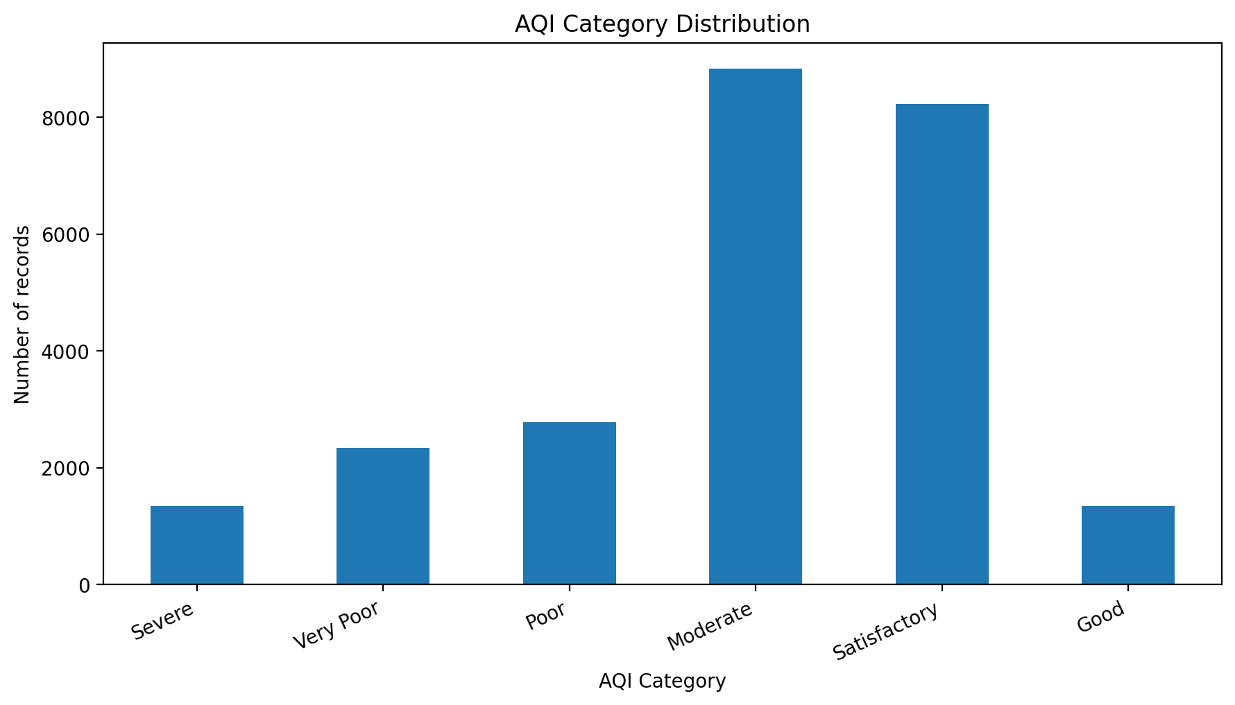
Fig. 1. AQI category distribution for records with an available AQI category; values are from a public analysis of the selected Kaggle dataset [7].
B. AQI Category Share
Using the reported category counts, Moderate accounts for approximately 35.53% of the classified records and Satisfactory for approximately 33.09%. The Severe and Very Poor groups together account for approximately 14.78% of the classified observations. These percentages are descriptive of the classified records in the cited analysis and should not be interpreted as a current national AQI estimate.
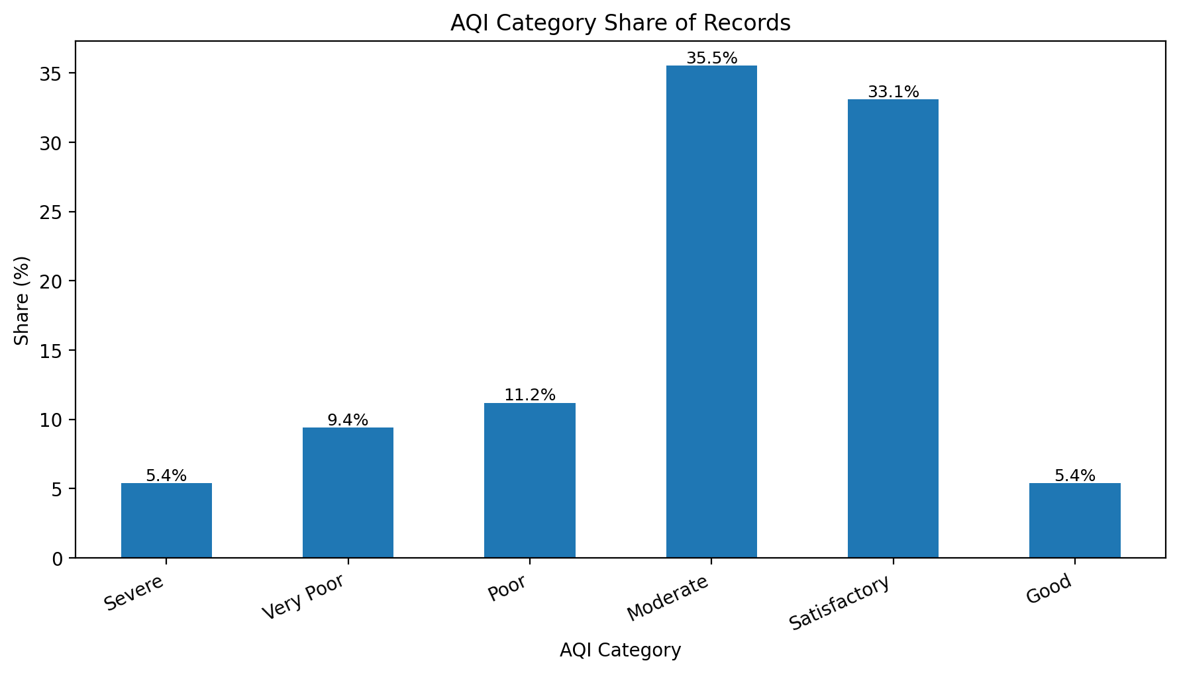
Fig. 2. Percentage share of AQI categories among classified records [7].
C. Average Pollutant Summary
A public Power BI analysis using the same city-day dataset reported average values of approximately 67.45 for PM2.5, 17.57 for NO, 14.53 for SO2, and 2.25 for CO [8]. Because these measures are expressed in the source dashboard's dataset units and are aggregated across the available records, they are presented here as reported summary statistics rather than as newly recomputed estimates.
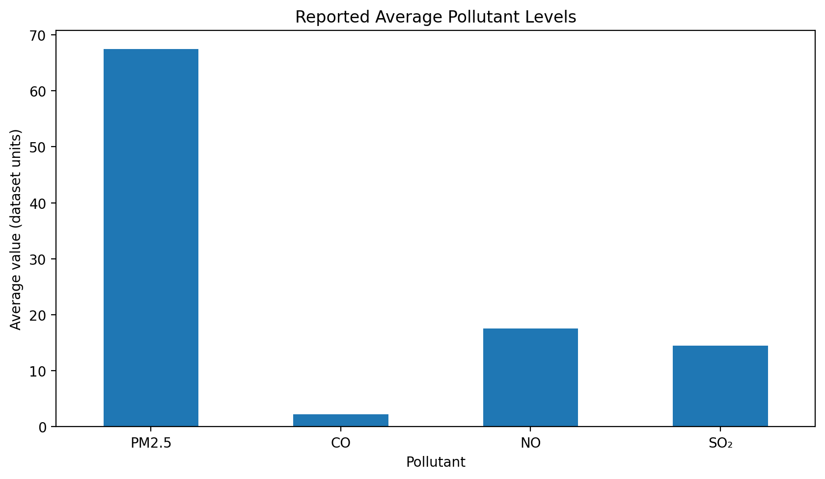
Fig. 3. Reported average values for selected pollutants from a public analysis of the same dataset [8].
D. City-wise AQI Comparison
The same public dashboard reported approximate average AQI values of 450 for Ahmedabad, 400 for Delhi, 350 for Patna, 73.02 for Coimbatore, 53.80 for Shillong, and 34.77 for Aizawl [8]. These values illustrate substantial variation among selected cities. Since the values come from an external dashboard analysis with its own aggregation and cleaning choices, they are used as reference values rather than as an independently recalculated ranking.
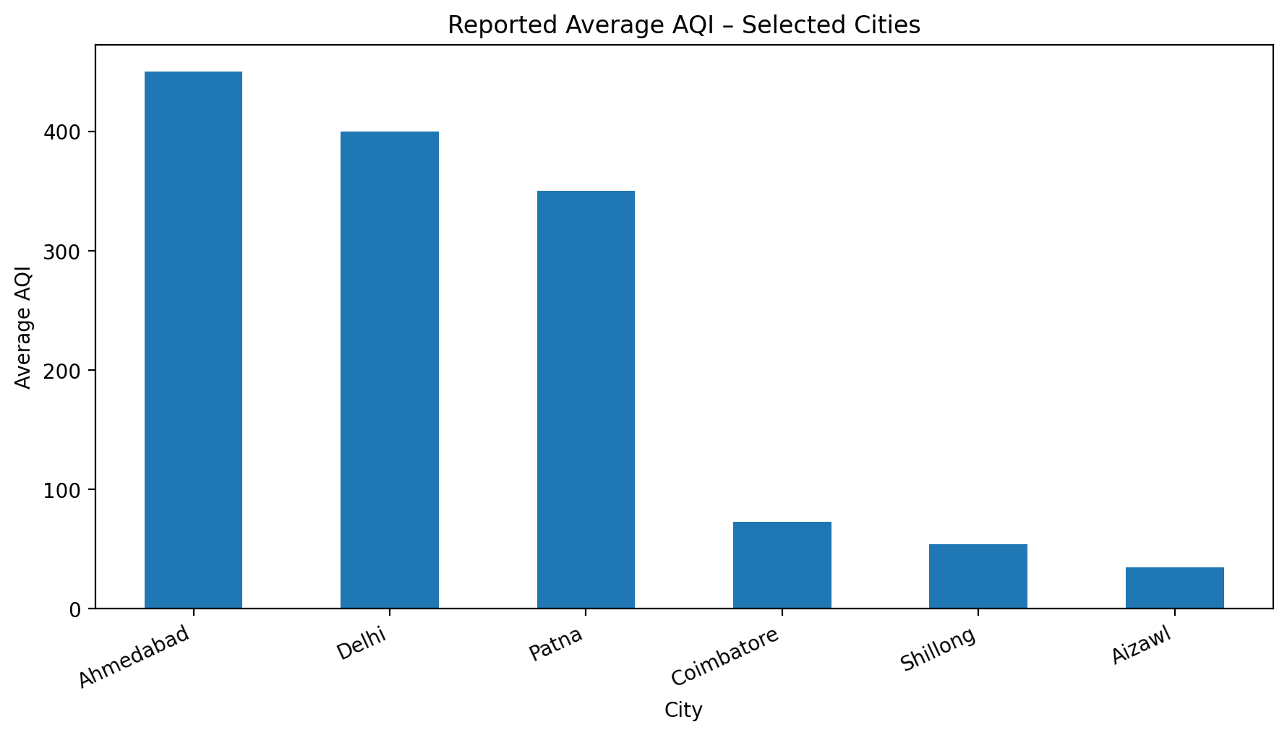
Fig. 4. Reported average AQI for selected cities; approximate values reproduced from a public dashboard analysis [8].
E. Interpretation
The results demonstrate three useful analytical observations. First, AQI categories are not evenly distributed: the reported Moderate and Satisfactory groups dominate the classified observations. Second, particulate matter is prominent in the reported pollutant summaries, with PM2.5 having a substantially larger numerical average than the selected gaseous pollutants. Third, city-level averages vary widely, showing why city grouping is important when interpreting a national dataset.
The findings also align with themes in prior literature. Visual exploration has been shown to reveal temporal and correlation patterns in air-pollution data [1], while Indian studies have identified differences in pollutant behavior across regions and seasons [3], [4]. The present project translates these ideas into a compact exploratory pipeline intended for academic analysis and visualization.
V. LIMITATIONS
• The selected city-day dataset contains missing observations, and the missingness is not uniform across pollutant variables [7]. Consequently, different statistics may use different numbers of valid observations.
• The figures in this paper use published or publicly reported summary results from analyses of the same Kaggle dataset [7], [8]. They should therefore be treated as benchmark/reference results unless the raw CSV is independently reprocessed using the exact same cleaning and aggregation rules.
• City-level averages can hide station-level variation, seasonal differences, and short-term pollution events. The dataset also covers the 2015–2020 period and therefore should not be treated as a direct description of air quality in 2026.
• The project is exploratory and does not attempt causal attribution or health-risk estimation. Correlation between pollutants should not be interpreted as proof of a common source or causal relationship.
VI. CONCLUSION
This paper presented an exploratory data-science workflow for analyzing and visualizing air quality across Indian cities using a publicly available dataset covering 2015–2020. The work is motivated by the need to make multi-pollutant environmental observations more understandable through systematic data inspection, descriptive statistics, and visual comparison. The methodology emphasizes data-quality assessment, awareness of missing observations, organization of date and city fields, AQI-category analysis, pollutant-level summaries, and city-wise visualization. The reference results discussed in this paper indicate that the Moderate and Satisfactory AQI categories form the largest groups in the reported classified records, while selected city averages show substantial variation. These observations illustrate the usefulness of grouping and visualization when exploring a multi-city dataset. They should, however, be interpreted within the limitations of the source dataset and the external aggregation methods used to produce the cited summaries.
Future work can extend the analysis with a fully reproducible preprocessing pipeline, station-level data, seasonal decomposition, correlation heatmaps, interactive dashboards, and machine-learning models for AQI or pollutant forecasting. A future version should also recompute every reported result directly from the raw CSV under a documented cleaning protocol so that all figures are independently reproducible.
ACKNOWLEDGMENT
The authors thank Dr. N. Sunanda for guidance and support in the development of this academic project. The authors also acknowledge the Central Pollution Control Board data made available through the public Kaggle dataset used for this study.
REFERENCES
[1] H. Li, H. Fan, and F. Mao, “A visualization approach to air pollution data exploration—A case study of air quality index (PM2.5) in Beijing, China,” Atmosphere, vol. 7, no. 3, p. 35, 2016, doi: 10.3390/atmos7030035.
[2] P. Jain and G. Kaur, “A learning-based visualization application for air quality evaluation during COVID’19 pandemic in open data centric services,” in Machine Learning Algorithms and Applications, 2021, pp. 1–22, doi: 10.1002/9781119769262.ch1.
[3] J. Persis and A. Ben Amar, “Predictive modeling and analysis of air quality—Visualizing before and during COVID-19 scenarios,” Journal of Environmental Management, vol. 327, p. 116911, 2023, doi: 10.1016/j.jenvman.2022.116911.
[4] A. Mathew, P. R. Gokul, P. R. Shekar, K. S. Arunab, H. G. Abdo, H. Almohamad, and A. A. Al Dughairi, “Air quality analysis and PM2.5 modelling using machine learning techniques: A study of Hyderabad city in India,” Cogent Engineering, vol. 10, no. 2, p. 2243743, 2023, doi: 10.1080/23311916.2023.2243743.
[5] G. Sharma, P. D. Parmar, A. K. Nema, P. Gargava, and S. H. Kota, “Systematic exposure bias in city-level air quality reporting revealed by 38 years of Indian observations,” Scientific Reports, vol. 16, p. 16042, 2026, doi: 10.1038/s41598-026-40057-w.
[6] R. Rao, “Air Quality Data in India (2015–2020),” Kaggle dataset, 2020. Available: https://www.kaggle.com/datasets/rohanrao/air-quality-data-in-india
[7] Learning Monk Blog, “Analysis: Air Quality in India,” 2020. Available: https://learningmonkblog.netlify.app/posts/analysis-air-quality-in-india/
[9] V. Kumar, V. Malyan, M. Sahu, B. Biswal, M. Pawar, and I. Dev, “Spatiotemporal analysis of fine particulate matter for India (1980–2021) from MERRA-2 using ensemble machine learning,” Atmospheric Pollution Research, vol. 14, no. 8, Art. no. 101834, 2023, doi: 10.1016/j.apr.2023.101834.
[10] G. Sharma, M. Gupta, P. Gargava, and S. H. Kota, “Mapping air quality trends across 336 cities in India: Insights from three decades of monitoring (1987–2019),” Environment International, vol. 191, Art. no. 108979, 2024, doi: 10.1016/j.envint.2024.108979.
[11] S. Jaganathan, A. Rajiva, H. Amini, J. de Bont, S. Dixit, A. Dutta, I. Kloog, K. J. Lane, J. S. Menon, A. Nori-Sarma, D. Prabhakaran, J. Schwartz, P. Sharma, M. Stafoggia, G. K. Walia, G. A. Wellenius, P. Prabhakaran, P. Ljungman, and S. Mandal, “Nationwide analysis of air pollution hotspots across India: A spatiotemporal PM2.5 trend analysis (2008–2019),” Environmental Research, vol. 264, Part 1, Art. no. 120276, 2025, doi: 10.1016/j.envres.2024.120276.
[8] J. Dhonde, “Powerbi-AirQuality-Dashboard,” GitHub repository, 2024. Available: https://github.com/JanviDhonde/Powerbi-AirQuality-Dashboard

